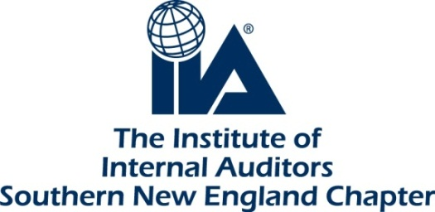
Annual SNE-IIA Scholarship Program
ELIGIBILITY and CRITERIA for 2023

Greetings!

The Southern New England Chapter of the Institute of Internal Auditors is proud to announce its Annual Scholarship Program for undergraduate and/or graduate collegiate students who are interested in the internal audit profession and have demonstrated academic achievement, personal excellence and civic mindedness. This year we are providing one $1,000 scholarship. Information about the scholarship is provided below, as well as the website to obtain the application. Please share this with the students enrolled in the accounting or audit curriculum and fellow educators.
Eligible students will:
- Be a permanent resident of Connecticut/Western Massachusetts or be currently enrolled in an accredited college/university located in Connecticut/Western Massachusetts
- Be currently enrolled in an accredited college or university
- Have completed or are expected to complete at least 15 credit hours in auditing, accounting, or finance courses of study, and have a minimum 3.0 overall cumulative grade point average (GPA)
- Include a letter of recommendation from either a professor, advisor or employer
- Provide transcript(s) from recently attended or currently attending colleges/universities
- Submit a short essay (no more than 500 words) describing your professional career goals

Scholarship funds must be used for educational expenses. Check will be made payable to the student and their school.

Students must include a letter of recommendation, transcript(s), and essay with the application.
Complete applications should be e-mailed by Sunday, January 15, 2023, to:
Chapter51@theiia.org

Only winners will be notified in February 2023. Formal presentation of the scholarships will be coordinated with the winners. A signed publicity release and W-9 form will be required upon acceptance of this award.

Application period closes SUNDAY, JANUARY 15, 2023. For more information on the application process and/or to obtain the application, go to Southern New England (theiia.org)

