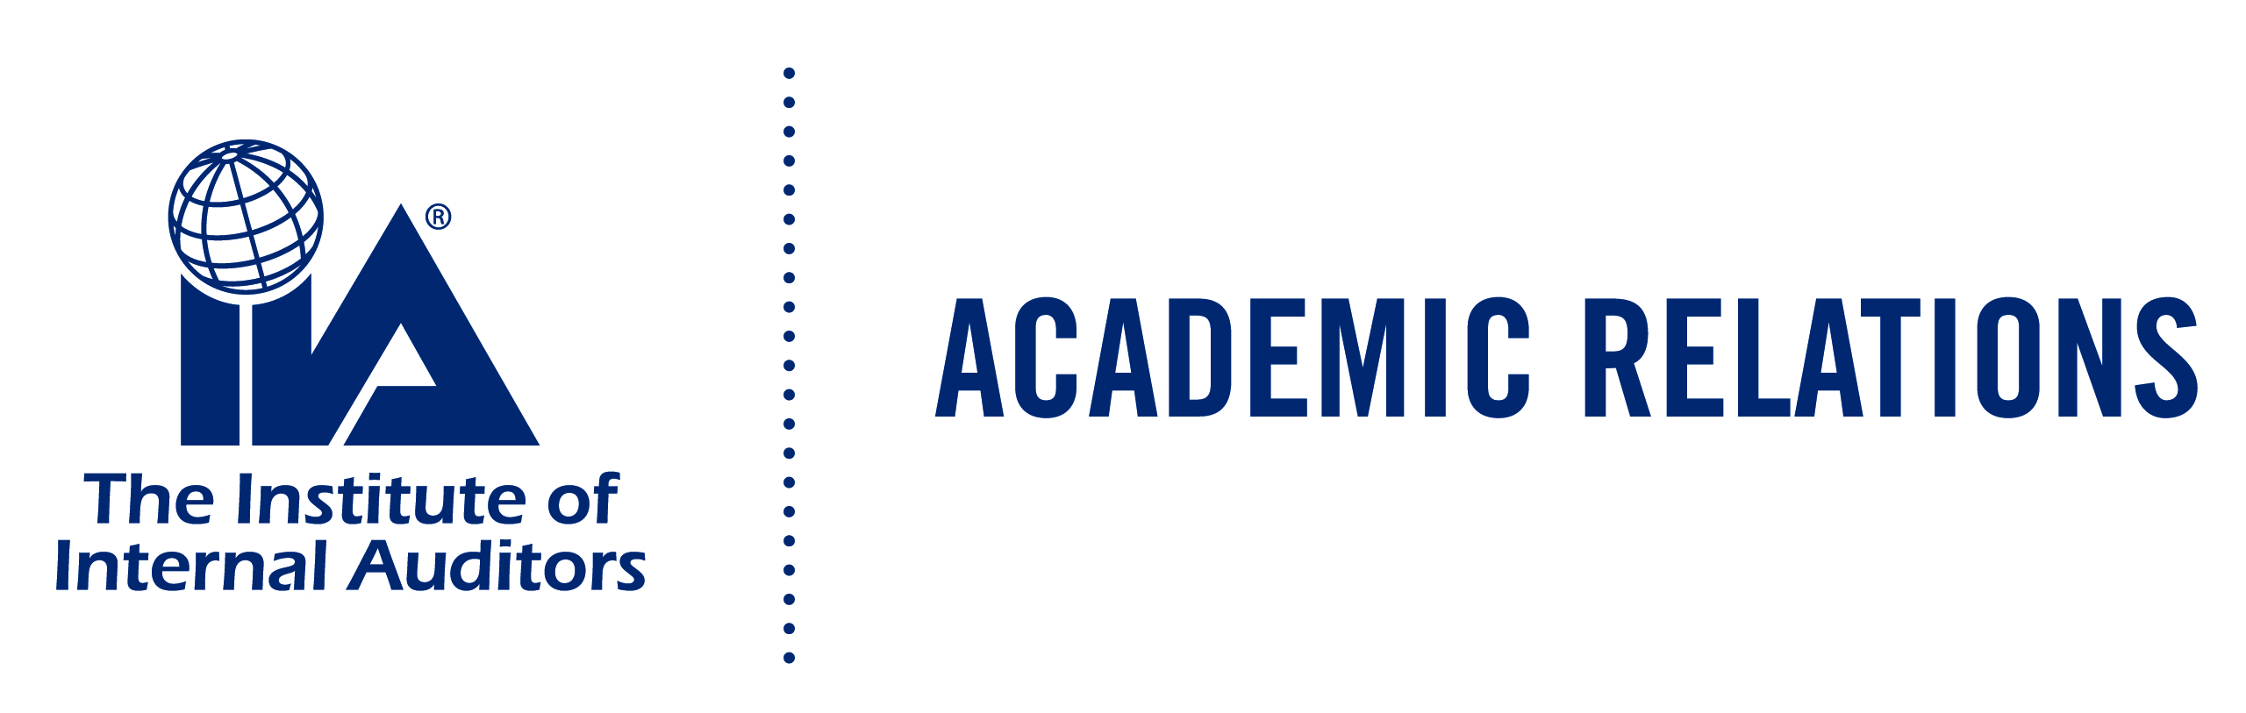
Academic Relations Case Study Request

Purpose: The Case Study is used in an academic setting to further the education in internal audit courses. To receive a case study please complete this form and agree to the guidelines below.

Educator Information:

Date Submitted:
Educator’s Name:

College/University:

Address:
Telephone Number:
E-mail address:

IIA Chapter/ Institute:
Submission Information for Academic Relation Case Study
Agreement: Suggested solutions are prohibited from being electronically posted or otherwise provided in any way for students to review. The solutions may be shown on a screen in class but must be under the control of the educator. By releasing the suggested solutions into the student population, the purpose and learning experience of the Case Study will be jeopardized for all universities.

Signature_____________________________________________________ Date______________________

Case Studies
Red Taxi Company: Audit of safety for a Taxi company. The case is designed to cover reporting
format and requires the preparation of an audit report.
Categories: Report Writing; Environment, Health, & Safety.

Tyronco Foundation: Evaluation and analysis of Internal Controls within an organization against
the COSO framework.
Categories: Internal Control, Governance, Interpersonal/ Communication and other soft skills, Evidence

Snap A Control: Identification of 31 varies types of controls. Case requires students to
identify and photograph 31 types of controls.
Categories: Internal Control, Interpersonal/ Communication and other soft skills.

Palms Trees Resorts Limited: Comprehensive case is very extensive with objectives that could be
presented as one big project or assigned as individual.
Categories: Internal Control, Sampling, IT systems, Report Writing, Environment, Health, & Safety.
Submit to Academic@theiia.org.

